The pets’ clinic

Authors:

Yoana Dimitrova Penkova

Diāna Bukša

Iván Menacho Gallardo

Álvaro Rubia Tapia

Manuel Cañizares Juan

University of Sevilla

2020

Index of contents

1. App description 4

2. Entity diagram 5

3. User stories 7

Index of figures

Figure 1 UML Diagram 5

# App description

Our goal regarding making improvements to the application is centered in the medical part of it. On one hand, we want to implement *Medical Record* which will contain data about the health of a given pet*, Interventions*, which will be another kind of a visit, but only for medical operations, and *Medicine*, which will contain the data of a given drug. We will also implement *Trainers* in order to give rehabilitations to the pets. At last we will implement an *Adoption* system, which will help to find a house for stray pets.

# Entity diagram

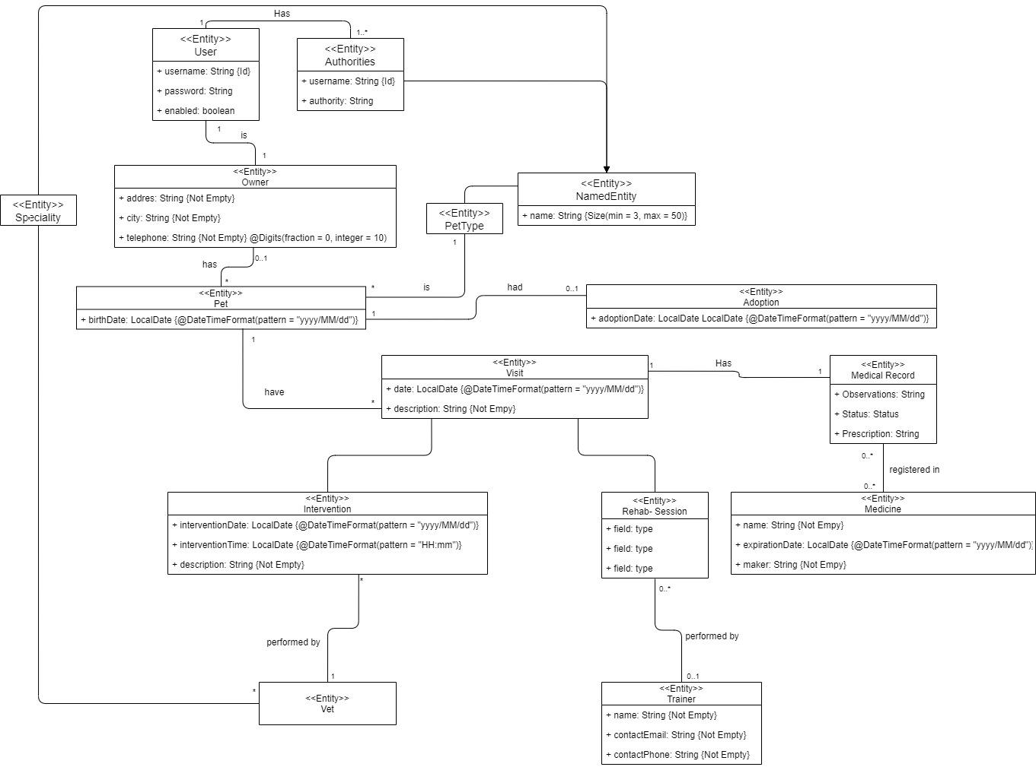

*Figure SEQ Figure \* ARABIC 1 UML Diagram*

Intervention: the idea is that in the pet clinic a Veterinarian will perform operations (if necessary) to a Pet.

- InterventionDate: This attribute saves the data of the date in which the intervention was performed

- InterventionTime: It contains the time the intervention lasted

- Description: The details about the intervention

MedicalReport: it contains all the data of a Pet, also contains all the Interventions, Medicines and Visits

- Date: The date of the creation of the Medical Report, that it is translated in the fisrt day a Pet came to the clinic

- Expiration Date: The date in which an animal rather dies or drop out from the pet clinic

Adoption: When a Pet has no owner is available for adoption

- AdoptionDate: The date in which a Pet is adopted

Medicine: A simple entity describing the medicament a Pet is given

- Name: The name of the medicine

- Expiration Date: Recommended date for consuming the product

- Maker: The company responsible of making the product

Trainer: When a Pet comes to the Pet clinic or comes out of a intervention and need rehabilitation a trainer is offer by the clinic

- Name: The name of the trainer

- Contact Email

- Contact Phone

# User stories

|  |  |
| --- | --- |
| **US 001** | **Vet adds a new medicine** |
| As a vet,  I want to add or delete medicines of the list of available ones,  so that I can know which medicine is available for prescription. | |
| Positive use case | A vet Anna goes to the medicine page and adds a new medicine Vaccine2 that from now on it will be available to be prescribed, and it is saved in the database. |
| Negative use case | A vet Anna goes to the medicine page to add a new medicine, but, after adding a new medicine, it does not show up in the all available medicine list and is not saved in the database because of an expiration date in the past (20/02/2001). |

|  |  |
| --- | --- |
| **US 002** | **Vet lists medicines** |
| As a vet,  I want to have access to a list of all medicines,  so that I can know which of them are available. | |
| Positive use case |  |
| Negative use case |  |

MEDICAL RECORD AND MEDICINE

|  |  |
| --- | --- |
| **US 003** | **Medical Record creation** |
| As a vet,  I want to create a medical record associated to a given visit  so that I can write down the observations obtained in that visit. | |
| Positive use case |  |
| Negative use case |  |

|  |  |
| --- | --- |
| **US 004** | **Owner sees pet’s medical record** |
| As an owner,  I want to have access to my pet´s medical records, which includes the medicines and visits he/she has had,  so that I can be up to date with his/her status. | |
| Positive use case | An owner John goes for his pet (Pipo)´s medical record and can see all medicine and visits that have been assigned to its pet and saved in the database. |
| Negative use case | Knowing that Pipo has had medicines and visits, the owner John goes for its medical record and there is nothing displayed. |

|  |  |
| --- | --- |
| **US 005** | **Trainers has access to medical records** |
| As a trainer,  I want to have access to my assigned pets´ medical records, which includes medicines and visits he/she has had,  so that I can know if he/she has had any injuries. | |
| Positive use case | A trainer John goes for his assigned pet(Rex)´s medical records and all the medicine and visits, that have been assigned and saved into the database before, are shown. |
| Negative use case | Knowing that the trainer(John)´s assigned pet, Rex, has had medicines and visits, that have been saved into the database before, the trainer goes for its medical records and there is nothing displayed. |

|  |  |
| --- | --- |
| **US 006** | **Vet sees a pet’s medical record** |
| As a vet,  I want to see the medical record of a certain pet,  so that I know all the interventions and medicine the pet had before. | |
| Positive use case | A vet Jane goes to the pet(Troy)’s medical record page and can see the pet’s medical record, the one that has been saved into the database before. |
| Negative use case | A vet Jane goes to the pet(Troy)’s medical record page and does not see its medical records, although it is not the pets’ first visit in the clinic and this pet has had several visits saved into the database before. |

|  |  |
| --- | --- |
| **US 007** | **Vet prescribes medicines to a pet** |
| As a vet,  I want to be able to prescribe medicines to the pets in the medical records,  so that I can treat a given affliction he/she may have. | |
| Positive use case | A vet Jane goes into the application and chooses the option of prescribing a medicine Vaccine1 to a cat Maggie. She enters the necessary information and has a successful new medicine entry. |
| Negative use case 1 | A vet Jane goes into the application and chooses the option of prescribing a medicine Vaccine1 to a cat Maggie. She doesn’t select one, so the new medicine entry is not performed. |
| Negative use case 2 | A vet Jane goes into the application and tries to add a new medicine Vaccine1 to the medical record MedicalRecord1 but she doesn’t enter a prescription, which is mandatory, so the new medicine entry is not performed. |

|  |  |
| --- | --- |
| **US 008** | **Pet type’s medicine checking** |
| As a vet,  I do not want to be able to prescribe any medicine which pet type is not the same as the pet in question  so that I can avoid misunderstanding and mistakes. | |
| Positive use case | A vet Sonia prescribes a medicine Vaccine3000 to a given pet Sasha with the same pet type and it is shown in the medical record. |
| Negative use case | A vet Sonia tries to prescribe a medicine Vaccine3000 to a given pet Sasha with the wrong pet type and those pet type medicines are shown. Then Sonia selects one and saves the new medicine but it is not saved in the database because of a pet type conflict. |

|  |  |
| --- | --- |
| **US 009** | **Vet changes a pet’s medical record** |
| As a vet,  I want to make changes to certain pet’s medical record,  so that I can update it if necessary. | |
| Positive use case | A vet Dana goes to the pet(Kiro)’s medical record page and is able to make changes in its medical record page and those changes are saved into the database. |
| Negative use case | A vet Dana goes to the pet(Kiro)’s medical record page and wants to update the medical record but the changes are not saved because some values are not valid. |

ADOPTION

|  |  |
| --- | --- |
| **US 010** | **User adopts a pet** |
| As a user,  I want to have access to a list of pets which are available for adoption,  so that I can adopt one and help him/her. | |
| Positive use case | A user John goes to the page, sees the listing of pets without owner and is able to chooses a dog Kate, adopt her that in the database this pet has an owner now. |
| Negative use case | A user John goes to the pets for adoption page, adopts a dog Kate, but the changes, such as a new owner of a pet, are not saved in the database because of an adoption date in the past, 20/02/2001. |

|  |  |
| --- | --- |
| **US 011** | **Vet manages homeless pets information** |
| As a vet,  I want to have access to the list of pets without an owner,  so that I can manage their adoption. | |
| Positive use case | A vet Ivan goes to the homeless pet(Ernie)’s personal page, adds it to the list of pets available for the adoption and this pet shows up in that list. |
| Negative use case | A vet Ivan goes to the homeless pet(Ernie)’s personal page and adds it to the list of pets available for adoption, but after adding to the list, this pet does not show up in the list because it hasn’t been saved because of a birth date in future (20/02/2200). |

|  |  |
| --- | --- |
| **US 012** | **Adoption procedure** |
| As a vet,  I want to create adoption records,  so that I can have a record of who adopts a given pet. | |
| Positive use case |  |
| Negative use case |  |

VETS

|  |  |
| --- | --- |
| **US 013** | **Administrator manages vets** |
| As an administrator,  I want to manage (add new/remove existing) vets,  so that I can guarantee that pets receive the best treatment. | |
| Positive use case | An administrator Martin goes to the vets’ page and can update an existing vet Lilly. After the changes are done, this vet is saved into the database and it’s properly shown in the listing. |
| Negative use case | An administrator Martin goes to the vets’ page and tries to update an existing vet but it’s not possible due to a name field left in blank. |

Interventions

|  |  |
| --- | --- |
| **US 014** | **Vet schedules a new intervention** |
| As a vet,  I want to make new interventions for a certain pet,  so that I can treat its illness. | |
| Positive use case | A vet Marta goes to the dog Drake’s intervention page and can add a new intervention for the pet and this intervention is saved into the database. |
| Negative use case | A vet Marta goes to the pet(Drake)’s intervention page, in order to add a new intervention, but after adding it, the intervention is not saved in the database as well as it does not show up in the in pets’ intervention list. |

|  |  |
| --- | --- |
| **US 015** | **Vet plans interventions** |
| As a vet,  I want to have access to a list of my arranged interventions,  so that I know what time slots I have available and schedule the next one. | |
| Positive use case | A vet Jane goes to the list page of her scheduled interventions and she can see all interventions that have been saved in the database before. |
| Negative use case | A vet Jane goes to the list page of scheduled interventions of another vet John and it produces an authorization error. |

|  |  |
| --- | --- |
| **US 016** | **Owners sees interventions** |
| As an owner,  I want to see all interventions my pet has had,  so that I am informed about my pets’ health state. | |
| Positive use case | An owner John goes for his pet(Rex)´s interventions, that have been previously saved in the database, and all of them are displayed. |
| Negative use case | Knowing that the pet Rex has had interventions, John as an owner goes to pet’s interventions page and none of them are displayed because a non-existing pet’s id has been passed. |

|  |  |
| --- | --- |
| **US 017** | **Owner sees vet’s personal information** |
| As an owner,  I want to see the personal information of the vet that has been assigned to an exact intervention that my pet has had,  so that I am informed of who is making the intervention and contact him/her if necessary. | |
| Positive use case | An owner Jane goes for her pet(Kristof)´s intervention, sees the vet that has been assigned to this intervention and can open and see this vet(John)’s personal information. |
| Negative use case | Knowing that the pet(Kristof) has had an intervention, Jane as an owner goes to an intervention page, opens one intervention but the assigned vet (John) is not showing up on the page. |

|  |  |
| --- | --- |
| **US 018** | **Vet sees pet’s visits** |
| As a vet,  I want to see all the visits certain pet has had,  so that I can choose the best treatment plan. | |
| Positive use case | A vet John goes to a certain pet(Sam)’s visits and can see the all visits that this pet has had and that have been saved to the database before. |
| Negative use case | John as a vet, knowing that a certain pet, Sam, has had some visits before, and that those visits have been saved into the database, goes to the visits’ page, but none are displayed. |

Trainers

|  |  |
| --- | --- |
| **US 019** | **Administrator manages trainers** |
| As an administrator,  I want to manage (add new/remove existing) trainers,  so that I can guarantee that pets receive the best trainings. | |
| Positive use case | An administrator Alise goes to the trainers’ page and can delete an existing trainer. After the trainer is deleted, it's no longer shown in the listing. |
| Negative use case | Alise as an administrator goes to the trainers’ page, removes a trainer Mike, but it is not deleted from the database and it still shows up in the list of trainers because he still has some pending training sessions. |

|  |  |
| --- | --- |
| **US 020** | **Unregistered user can see Trainers** |
| As an unregistered user,  I want to see the available trainers,  so that I can know the services the veterinary provides. | |
| Positive use case | An owner John goes to the page of available trainers and is able to see all the available trainers that have been previously marked as available. |
| Negative use case | An owner John goes to the page of available trainers and is able to see a not available trainer Jane among others. |

rehab session

|  |  |
| --- | --- |
| **US 021** | **Training sessions organization** |
| As a Trainer,  I want to organize rehabilitation sessions,  so that I can help a pet recover from a certain injury, | |
| Positive use case | A trainer Mary goes to the list page of her scheduled rehabs, adds a rehab and she can see just added and all previous rehabs that have been saved in the database before. |
| Negative use case | A trainer Mary goes to the list page of scheduled rehabs, wants to add a new rehab, but an error is shown. |

|  |  |
| --- | --- |
| **US 022** | **Trainer plans rehabilitation sessions** |
| As a trainer,  I want to have access to a list of my arranged rehabilitation sessions,  so that I know what time slots I have available and schedule the next one. | |
| Positive use case | A trainer Isabella goes to the list page of her scheduled rehabs and can see all the rehabs she has had and the rehabs she will have. |
| Negative use case | A trainer Isabella goes to the page of her scheduled rehabs but an error is shown. |

|  |  |
| --- | --- |
| **US 023** | **Owner sees rehabilitation session** |
| As an owner,  I want to see all rehabilitation session my pet has had or will have,  so that I am informed about my pets’ health state. | |
| Positive use case | An owner Jack goes to his pets page and can see a list of the rehabs his pets has had or will have |
| Negative use case | An owner Jack goes to his pets page, but an unexpected error is shown |

|  |  |
| --- | --- |
| **US 024** | **Owner sees trainer’s personal information** |
| As an owner,  I want to see my pet’s trainer,  so that I can see his/her personal information and contact him/her if necessary. | |
| Positive use case | An owner, Jane, goes to her pet(Bert)’s trainer page and sees the assigned trainer, John. |
| Negative use case | Jane as an owner, knowing that her pet has a trainer (John) assigned, goes to the trainers’ page but the trainer is not showing up. |

|  |  |
| --- | --- |
| **US 025** | **Trainers sees pet’s visits** |
| As a trainer,  I want to have access to my assigned pets´ visits,  so that I can manage the workload in the training. | |
| Positive use case | A trainer Jane goes for her assigned pet (Meg)´s visits and all of them, that are also saved in the database, are displayed. |
| Negative use case | Knowing that the trainer(Jane)´s assigned pet (Meg) has had some visits, that have been previously saved in the database, she goes for Meg´s visits and none are displayed. |